THOSE are Data that been verfified to be accurate, not totcs not estimation, not prediction.IT IS ACCURATE. And their date displayed behind each

- July 4, 2020
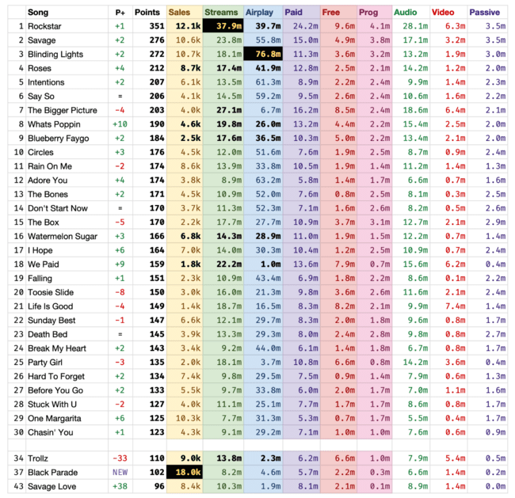

- July 11, 2020
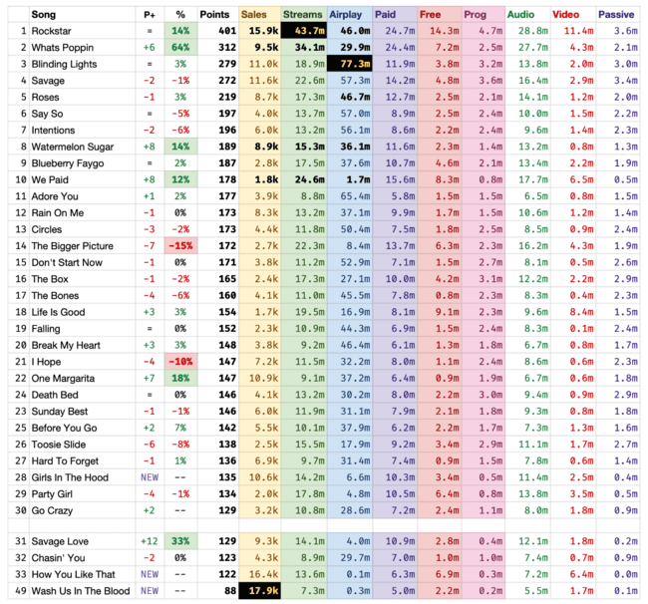

- July 18, 2020
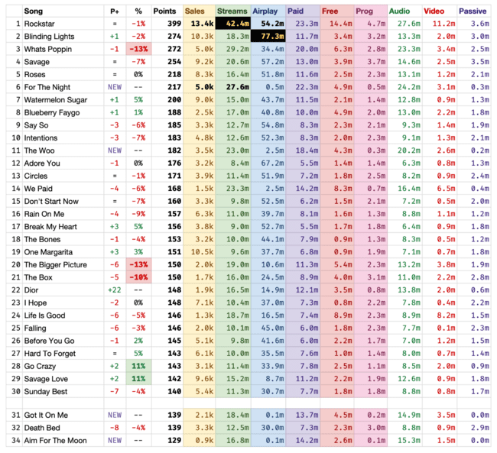

- July 25, 2020
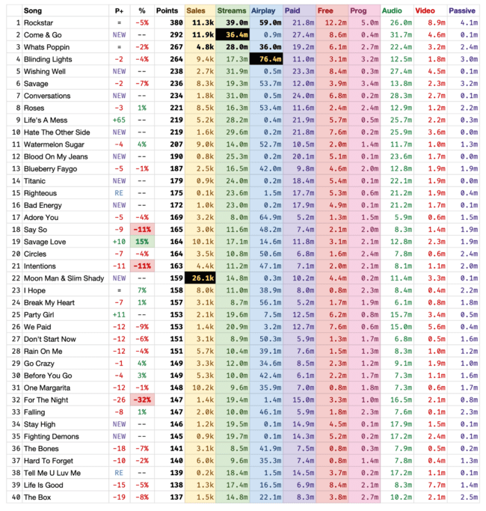

- August 22, 2020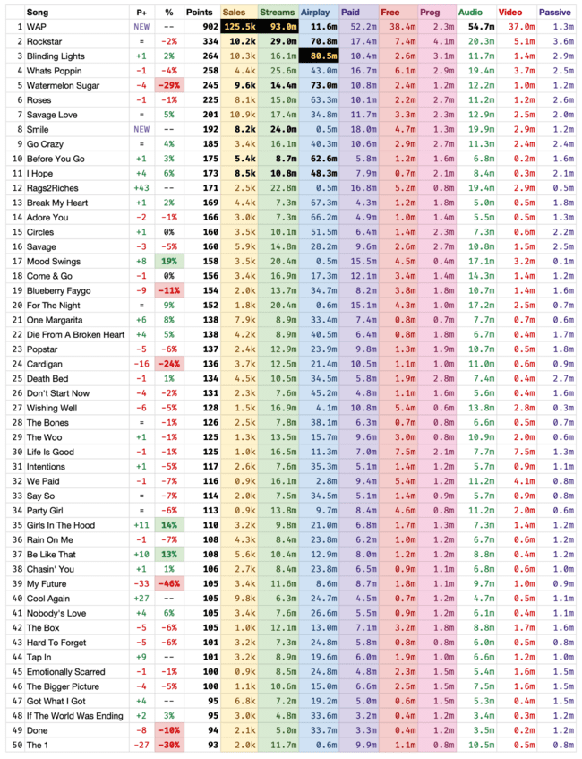
- - August 1, 2020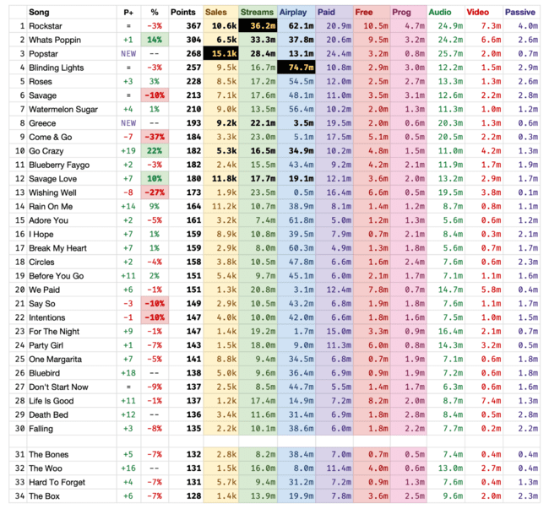- august 29, 2020

- 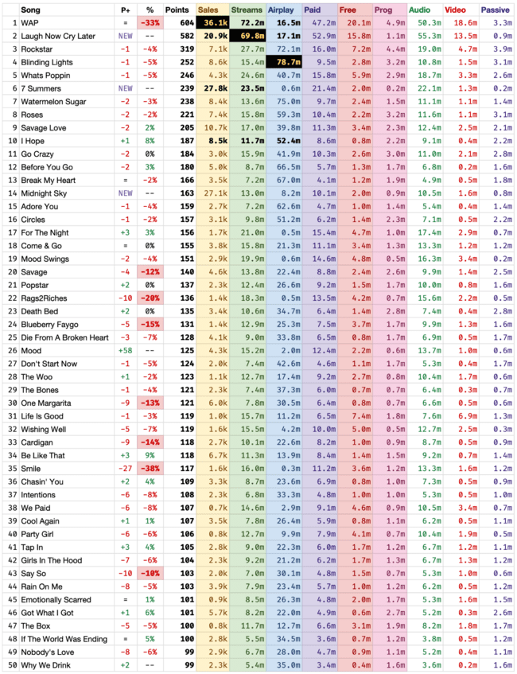

-august 8, 2020

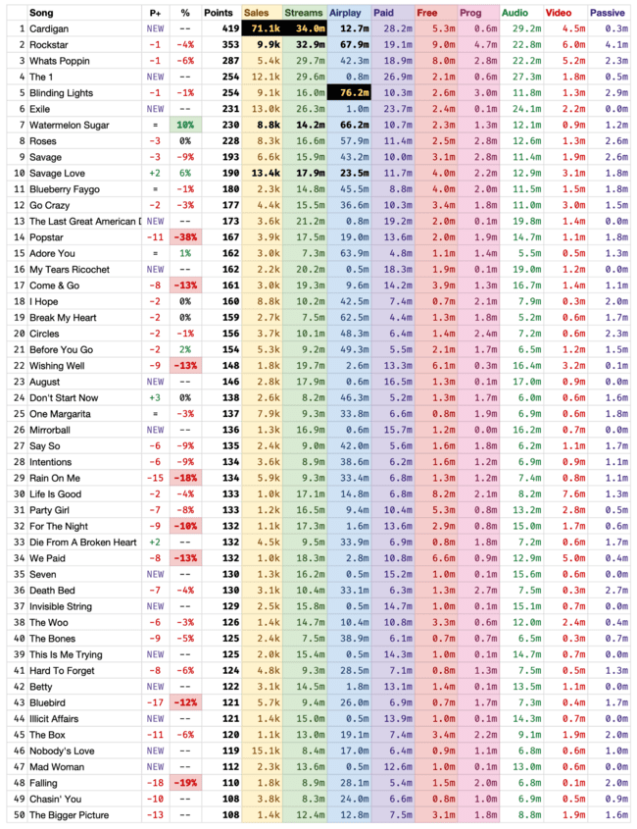

- Sep 5, 2020
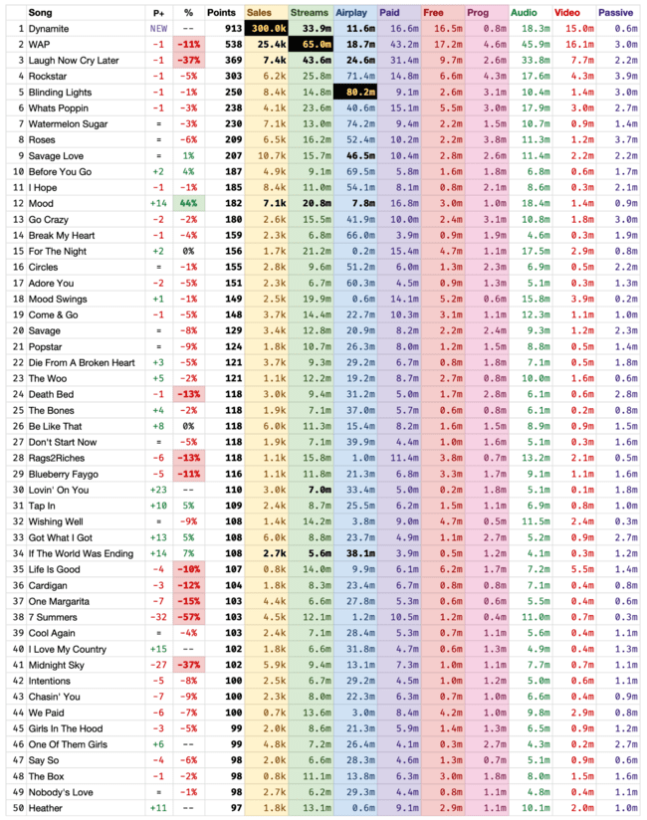

- Sep 12, 2020
